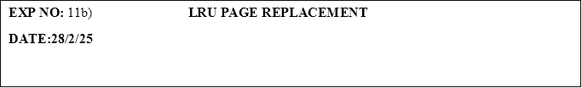

**PROGRAM:**

#include <stdio.h>

#define MAX 10

void lruPageReplacement(int pages[], int n, int capacity) {

int frames[capacity], counter[MAX] = {0}, pageFaults = 0;

// Initialize frames

for (int i = 0; i < capacity; i++) {

frames[i] = -1;

}

printf("Page Reference String: ");

for (int i = 0; i < n; i++) {

printf("%d ", pages[i]);

}

printf("\n");

for (int i = 0; i < n; i++) {

int found = 0;

// Check if the page is already in memory

for (int j = 0; j < capacity; j++) {

if (frames[j] == pages[i]) {

found = 1;

counter[j] = i; // Update the counter with the current index (recent use)

break;

}

}

// If page is not found, replace it using LRU

if (!found) {

int lru = 0;

for (int j = 1; j < capacity; j++) {

if (counter[j] < counter[lru]) {

lru = j;

}

}

frames[lru] = pages[i];

counter[lru] = i; // Update the counter for the replaced page

pageFaults++;

}

// Display the frames after each page reference

for (int j = 0; j < capacity; j++) {

printf("%d ", frames[j]);

}

printf("\n");

}

printf("\nTotal Page Faults = %d\n", pageFaults);

}

int main() {

int pages[MAX], n, capacity;

printf("Enter number of frames: ");

scanf("%d", &capacity);

printf("Enter number of pages: ");

scanf("%d", &n);

printf("Enter reference string: ");

for (int i = 0; i < n; i++) {

scanf("%d", &pages[i]);

}

lruPageReplacement(pages, n, capacity);

return 0;

}

**OUTPUT:**

Enter number of frames: 3

Enter number of pages: 5

Enter reference string: 2

3

4

3

7

Page Reference String: 2 3 4 3 7

2 -1 -1

3 -1 -1

3 4 -1

3 4 -1

3 4 7

Total Page Faults = 4

1

231801504                                                                                                                                             CS23431